Phase 5: Implement Client Script and UI Policy (Incident) in ServiceNow
Project Development Phase

1. Introduction
The Project Development Phase focuses on the practical implementation of the Implement Client Script & UI Policy (Incident) micro project in the ServiceNow platform. During this phase, UI Policies and Client Scripts are created and configured to control Incident form behavior, automate field updates, enforce mandatory information, and prevent invalid changes.
The development process is divided into six tasks. Each task implements a specific requirement and contributes to improving the accuracy, consistency, and usability of Incident records.
2. Development Environment
The project is developed using the ServiceNow platform with administrative or configuration access.
Component | Description
Platform | ServiceNow
Module | Incident Management
Configuration | System UI
UI Policies | Control field behavior based on conditions
UI Policy Actions | Configure individual field properties
Client Scripts | Execute client-side logic
Form Validation | Check required information before saving
3. Development of UI Policy
Task 1
Create UI Policy – High Impact Control
The first development task is to create a UI Policy named High Impact Control on the Incident table. This policy applies additional controls whenever the Impact field is set to High.
Development procedure:
- Log in to the ServiceNow instance with configuration access.
- Navigate to System UI → UI Policies.
- Click New to create a UI Policy.
- Enter the name as High Impact Control.
- Select Incident as the table.
- Set Active to true.
- Configure the condition as Impact is 1 – High.
- Enable Reverse if false.
- Click Submit to save the policy.
Expected development result
The UI Policy is activated when an Incident has High Impact. When the condition becomes false, the field changes controlled by the policy are reversed.
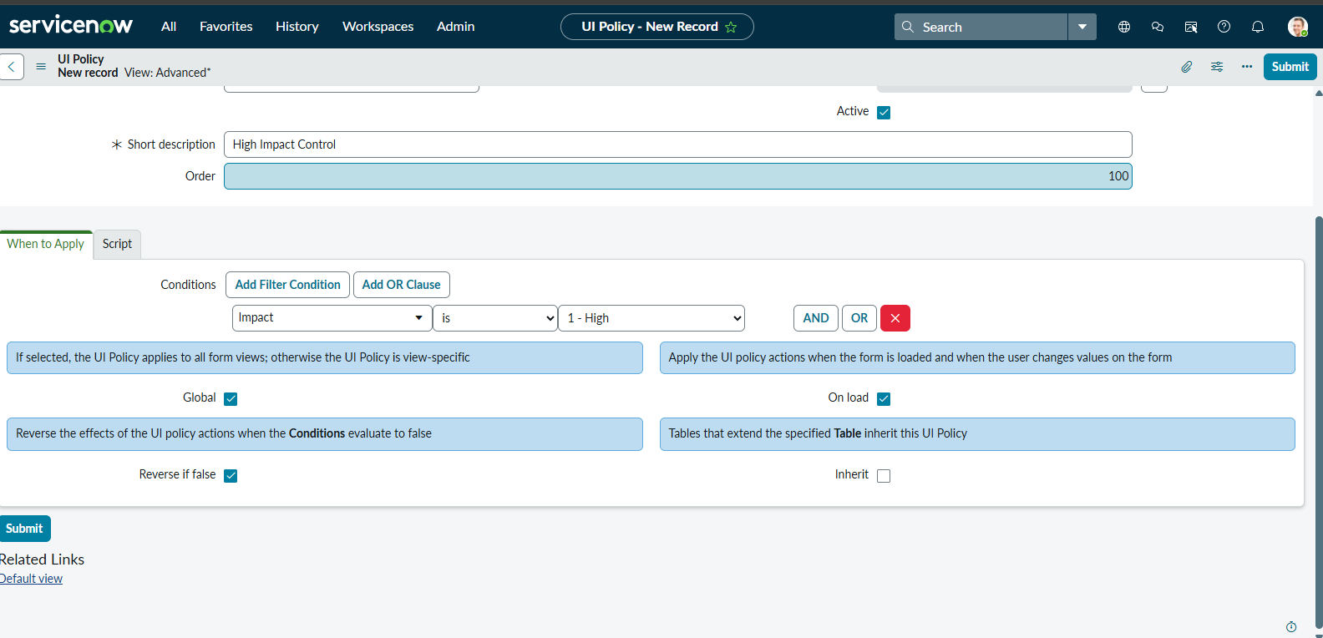

4. Development of UI Policy Actions
Task 2
Configure the Urgency Field
After creating the UI Policy, a UI Policy Action is added to control the Urgency field.
Development procedure:
- Open the High Impact Control UI Policy.
- Navigate to the UI Policy Actions related list.
- Click New.
- Select Urgency as the field name.
- Set Read-only to true.
- Leave the Visible setting unchanged.
- Click Submit.
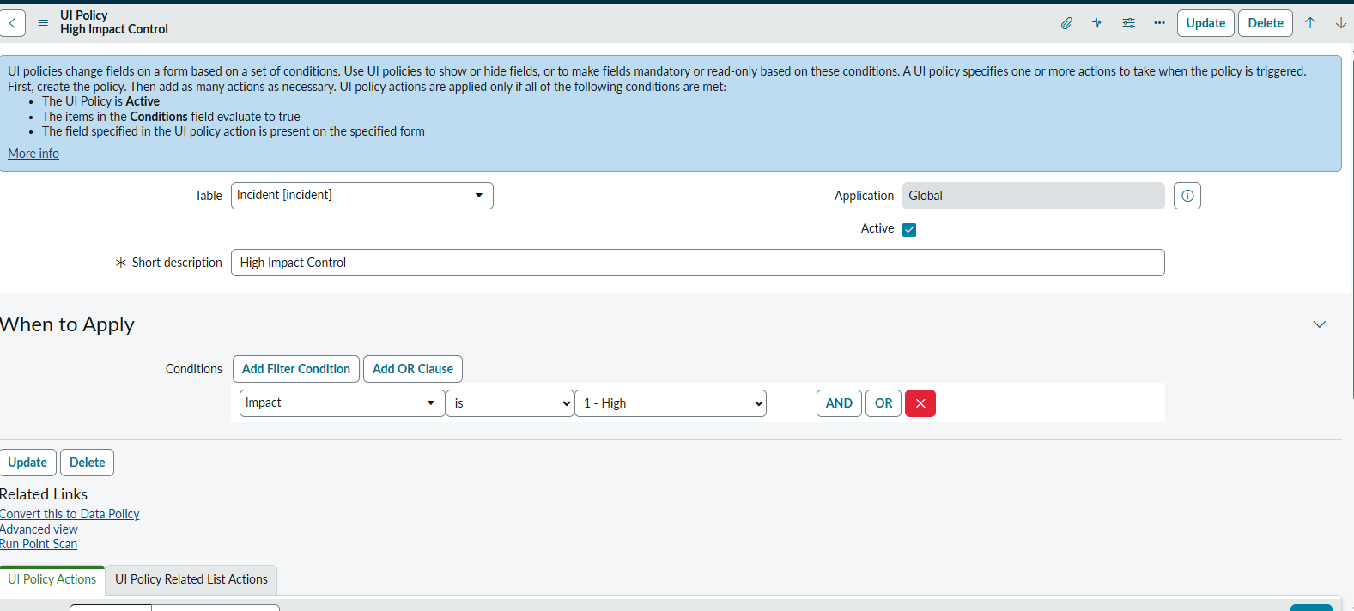
Expected development result:
When Impact is High, the Urgency field becomes read-only. The field remains visible to the user, but the user cannot manually edit it while the policy condition is true. When the condition becomes false, the read-only setting is reversed.
5. Development of onChange Client Script
Task 3
Auto Set Urgency for High Impact
The onChange Client Script automatically sets Urgency to High when the user changes Impact to High. It runs when the Impact field changes on the Incident form.
Configuration details:
Property | Value
Name | Auto set urgency for high impact
Table | Incident
Type | onChange
Field name | Impact
Active | true
Script implementation:
function onChange(control, oldValue, newValue, isLoading) {
if (isLoading || newValue == '') {
return;
}

if (newValue == '1') {
g_form.setValue('urgency', '1');
g_form.addInfoMessage(
'Urgency set to High for High impact incident.'
);
}
}
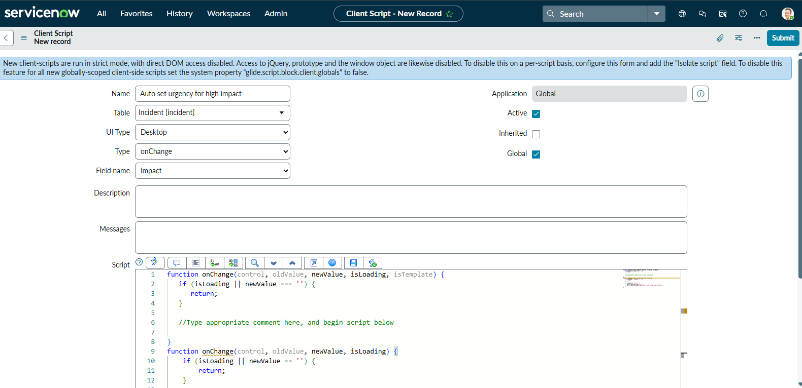
Development procedure:
- Navigate to System UI → Client Scripts.
- Click New.
- Enter the Client Script name.
- Select Incident as the table.
- Select onChange as the script type.
- Choose Impact as the field name.
- Set Active to true.
- Paste the script into the Script field.
- Click Submit.
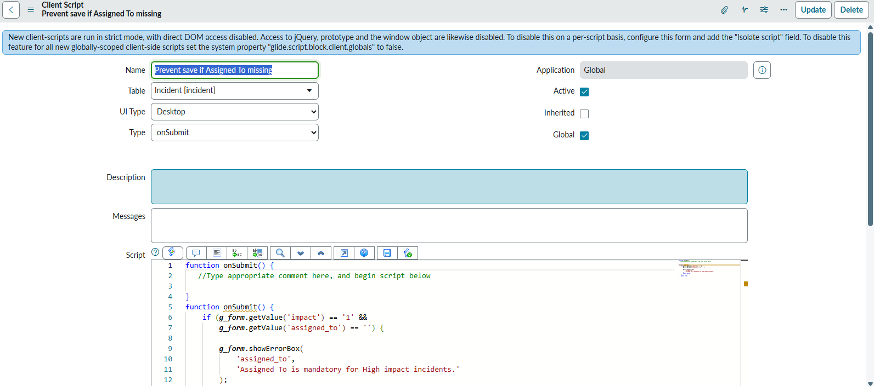
Expected development result:
When a user changes Impact to High, the script sets Urgency to High and displays an informational message. The script does not execute its update when the form is initially loading or the new value is empty.
6. Development of onSubmit Client Script
Task 4
Prevent Saving if Assigned To Is Missing
The onSubmit Client Script validates the Assigned To field before saving an Incident. If Impact is High and Assigned To is empty, the script displays an error and prevents submission.
Configuration details:
Property | Value
Name | Prevent save if Assigned To missing
Table | Incident
Type | onSubmit
Active | true
Script implementation:
function onSubmit() {
if (g_form.getValue('impact') == '1' &&
g_form.getValue('assigned_to') == '') {

g_form.showErrorBox(
'assigned_to',
'Assigned To is mandatory for High impact incidents.'
);
return false;
}

return true;
}
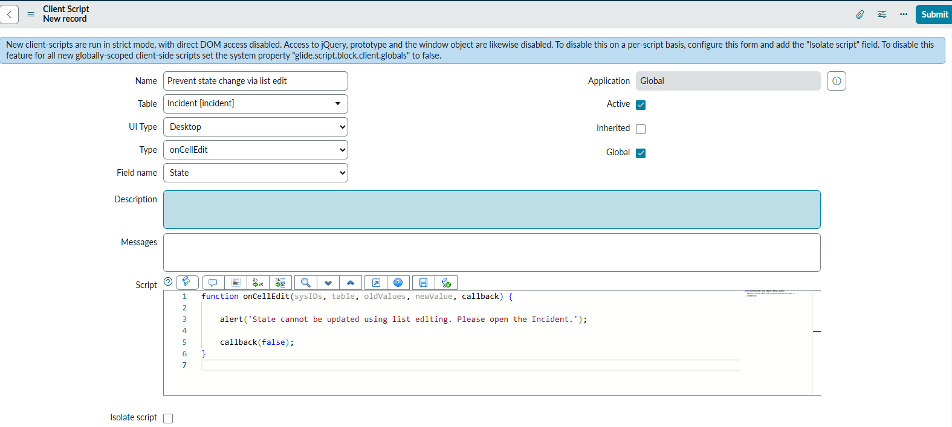
Development procedure:
- Navigate to System UI → Client Scripts.
- Click New.
- Enter the script name.
- Select Incident as the table.
- Select onSubmit as the type.
- Set Active to true.
- Paste the script into the Script field.
- Click Submit.
Expected development result:
If the Incident has High Impact and Assigned To is empty, the record is not submitted and an error message appears beside the Assigned To field. If Assigned To is filled or Impact is not High, the script allows submission.
Development note
The UI Policy makes Assignment Group mandatory, while this Client Script checks Assigned To. These are two separate fields and two separate validation rules in the project.
7. Development of onCellEdit Client Script
Task 5
Prevent State Changes Through List Editing
The onCellEdit Client Script is configured to block direct changes to the State field from the Incident list view. It displays an alert and rejects the list edit.
Configuration details:
Property | Value
Name | Prevent state change via list edit
Table | Incident
Type | onCellEdit
Field name | State
Active | true
Script implementation:
function onCellEdit(sysIDs, table, oldValues,
newValue, callback) {

alert(
'State cannot be updated using list editing. Please open the Incident.'
);

callback(false);
}

Development procedure:
- Navigate to System UI → Client Scripts.
- Click New.
- Enter the script name.
- Select Incident as the table.
- Select onCellEdit as the type.
- Choose State as the field name.
- Set Active to true.
- Paste the script into the Script field.
- Click Submit.
Expected development result:
When a user attempts to edit State directly in the Incident list, an alert is displayed and the callback rejects the change. Users can instead open the Incident form to update the State field.
8. Integration of Project Components
The project combines the UI Policy, UI Policy Action, and Client Scripts to control different aspects of the Incident form.

Component | Responsibility
High Impact Control UI Policy | Activates field controls when Impact is High
Assignment Group UI Policy Action | Makes Assignment Group mandatory
Urgency UI Policy Action | Makes Urgency read-only
onChange Client Script | Automatically sets Urgency to High
onSubmit Client Script | Prevents submission when Assigned To is missing for High Impact
onCellEdit Client Script | Blocks State changes through list editing
Together, these components provide conditional field behavior, automatic updates, form validation, and restrictions on list editing.
9. Development Testing and Verification
Task 6
Test the Configuration
After implementing the configurations, each behavior is tested to check whether it works according to the project requirements.
Testing checklist
0 / 5 completed
1. Mandatory enforcement
Set Impact to High, leave Assigned To empty, and attempt to submit. Verify that submission is blocked and an error appears.
2. Successful save
Set Impact to High, fill Assigned To, and submit. Verify that the Incident saves successfully.
3. Reverse condition
Change Impact from High to Medium. Verify that Assignment Group is no longer mandatory and Urgency becomes editable.
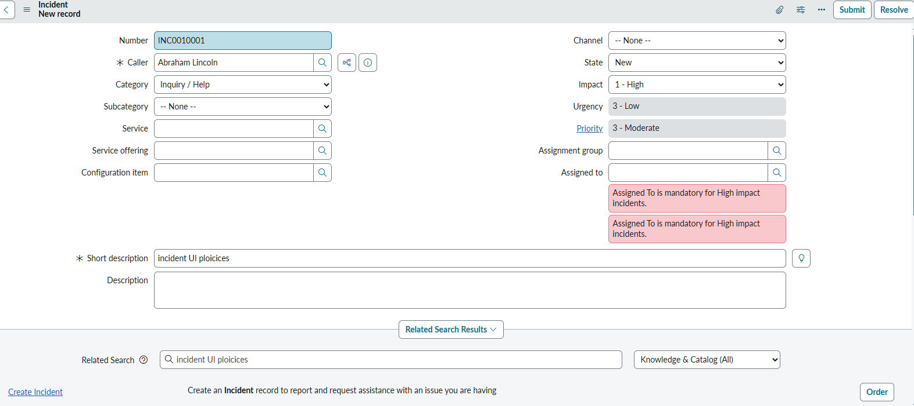
4. List edit blocking
In Incident → All, double-click State. Verify that an alert appears and the value remains unchanged.
5. Form-based update
Open an Incident form, change State, and click Update. Verify that the form-based change saves.
Reset checklist
The testing process verifies the required behavior of each configuration:
- Mandatory enforcement: Confirms the onSubmit script blocks incomplete High Impact Incidents.
- Successful save: Confirms that valid Incident information can be submitted.
- Reverse condition: Confirms that the UI Policy actions are reversed when Impact is no longer High.
- List edit blocking: Confirms that direct State changes from the list are rejected.
- Form-based update: Confirms that State can still be changed through the Incident form.
10. Development Outcome
The development phase produces a configured Incident form with conditional controls and client-side validation. The UI Policy and its actions manage Assignment Group and Urgency behavior, while the Client Scripts automate Urgency, validate Assigned To during submission, and prevent State changes through list editing.
The configuration is designed to improve data completeness and consistency while guiding users toward the expected Incident entry process. The testing checklist can be used to record the results after the configurations are executed in the ServiceNow instance.
11. Conclusion
The Project Development Phase implements the main features of the Implement Client Script & UI Policy (Incident) micro project. By creating a UI Policy, configuring UI Policy Actions, and developing onChange, onSubmit, and onCellEdit Client Scripts, the project demonstrates how ServiceNow can apply business rules directly through the user interface. These controls support consistent Incident data entry, reduce incomplete submissions under the specified conditions, and provide a structured approach to updating Incident records.

